Xampp software (mysql apache server, php) its include all

xampp(full form)
x-crosss platform
a-apache
m-mysql
p-php
p-perl
Enviormnt setup:
1]XAMPP Download & Install
https://sourceforge.net/projects/xampp/files/XAMPP%20Windows/8.0.28/xampp-windows-x64-8.0.28-0-VS16-installer.exe
2] After installing the XAMPP software:
1) Extract opencart-opencart-4.1.0.3.zip file to folder opencart-opencart-4.1.0.3
2) copy folder opencart-opencart-4.1.0.3 to C:\xampp\htdocs
3) rename folder C:\xampp\htdocs\opencart-opencart-4.1.0.3 to C:\xampp\htdocs\opencart(removed version look like opencart.php)

4) Rename following files
a) C:\xampp\htdocs\opencart\upload\config-dist.php to config.php
b) C:\xampp\htdocs\opencart\upload\admin\config-dist.php to config.php
5) Connect Database:
a) Open url : http://localhost/phpmyadmin/
b) create new database "openshop"
6) Establish connection between open cart application and database a) open site url: http://localhost/opencart/
7) don’t forget delete your install folder the name is install
when below error is coming in window.
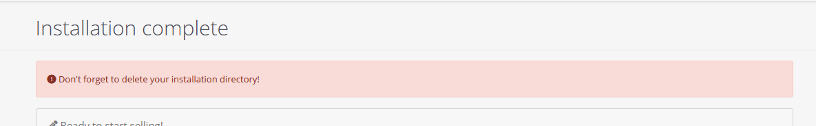
C:\xampp\htdocs\opencart\upload (install) delete this install folder
* I want to access frontend module:
http://localhost/opencart/
then click on upload……>
* I want to access backend admin module:
http://localhost/opencart/upload/admin/
un: admin
pwd: admin
Connect Database:
1] I am using mysql workbench 8.0 CE :
install the software into system:
https://dev.mysql.com/downloads/workbench/

click on +sign
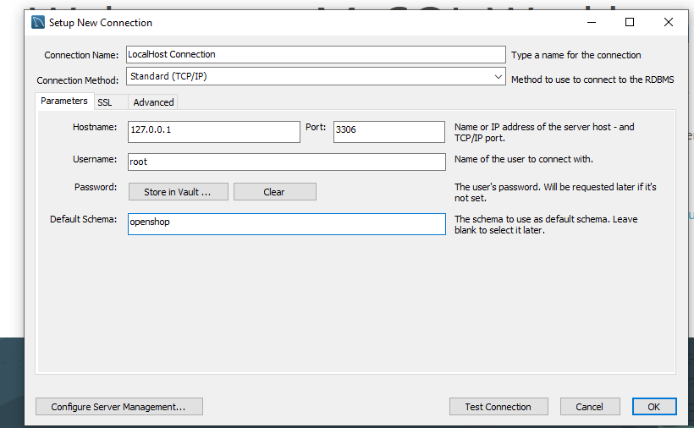
default scema: openshop is a my databse name
then click on ----------- Test connection ------------ click on Ok
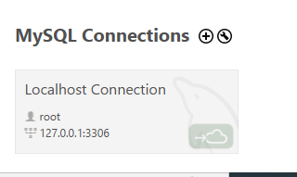
created above database:
then click on this--------- continue anyway(click)------ page open
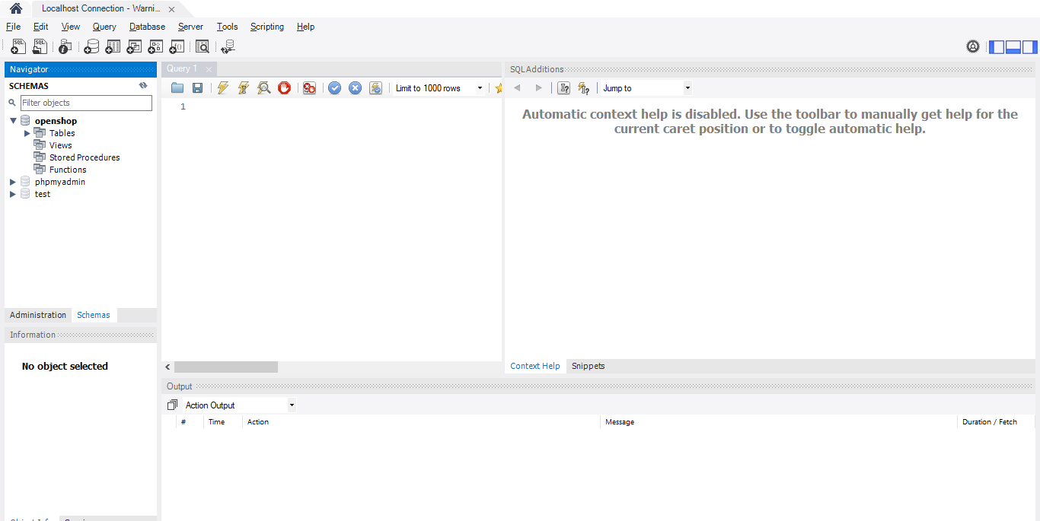
you write a query and performed database testing.
2}] method to connect database:
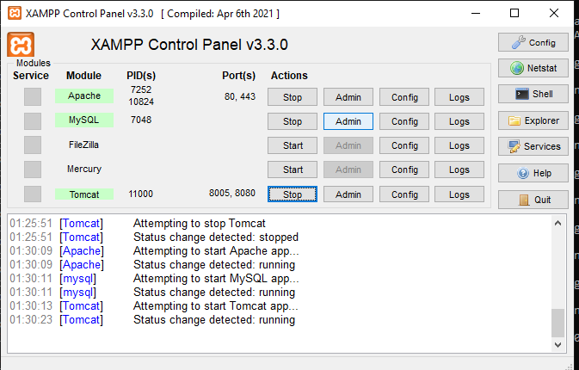
I mysql section click on admin--
directly open a link http://localhost/phpmyadmin/
or we can manually Enter in browser
open databse :
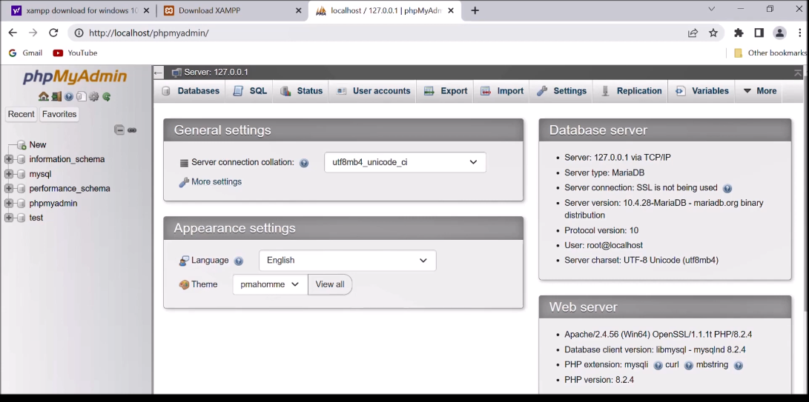

then click on new-----(create a databse name like openshop)
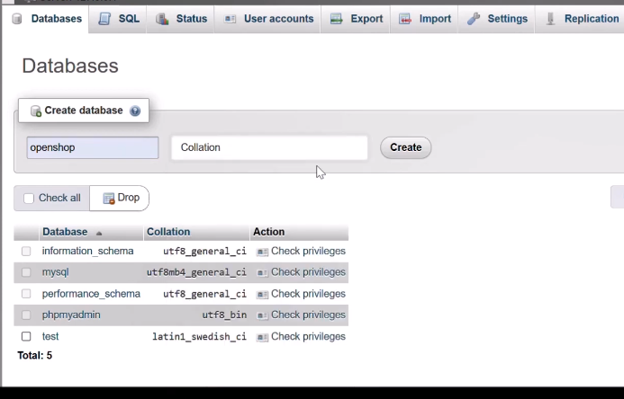
name like openshop -> select collation and then click on create your database created successfully
then click on schema section and write a sql query so you performned database testing here.

